**Project Design Phase-II**

**Data Flow Diagram &User Stories**

|  |  |
| --- | --- |
| Date | 03October 2022 |
| Team ID | PNT2022TMID38914 |
| Project Name | Project - News Tracker Application |
| Maximum Marks | 4 Marks |

**Data Flow Diagrams:**

A Data Flow Diagram (DFD) is a traditional visual representation of the information flows within a system. A neat and clear DFD can depict the right amount of the system requirement graphically. It shows how data enters and leaves the system, what changes the information, and where data is stored.

**Example: DFD Level 0 (Industry Standard)**

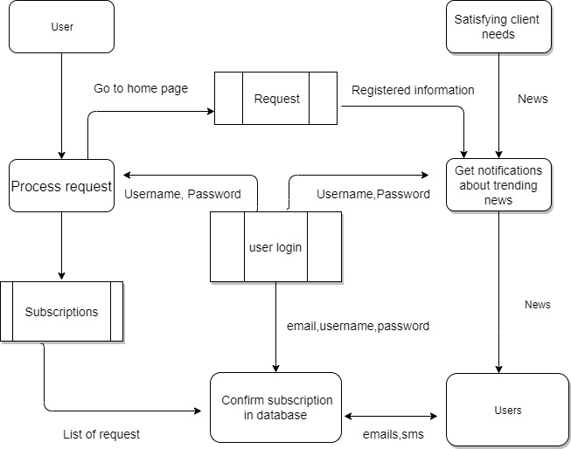

**Example: [(Simplified)](https://developer.ibm.com/patterns/visualize-unstructured-text/)**

Satisfying client needs

Login

User

Processing

request

Request

**User Stories**

Use the below template to list all the user stories for the product.

| **User Type** | **Functional Requirement (Epic)** | **User Story Number** | **User Story / Task** | **Acceptance criteria** | **Priority** | **Release** |
| --- | --- | --- | --- | --- | --- | --- |
| Customer (Searchig news) | Registration | USN-1 | As a user, I can register for the application by entering my email, password, and confirming my password. | I can access my account / dashboard | High | Sprint-1 |
|  |  | USN-2 | As a user, I will receive confirmation email once I have registered for the application | I can receive confirmation email & click confirm | High | Sprint-1 |
|  |  | USN-3 | As a user, I can register for the application through their given website | I can register & access the dashboard with Gmail or in Browser Login | Low | Sprint-2 |
|  |  | USN-4 | As a user, I can register for the application through Gmail |  | Medium | Sprint-1 |
|  | Login | USN-5 | As a user, I can log into the application by entering email & password | I can view all types of informations through this application | High | Sprint-1 |
|  | Dashboard | USN-6 | To see their histories about recently viewed, updates for search related news, current progress ,feedback |  |  |  |
| Customer (Web user) | Browser | USN-7 | Have interactive medium between client and server | I have a clarity to use this application and easily resolve my specific issues | high | Sprint-1 |
| Customer Care Executive | Chat bot | USN-8 | Rectify the issues related subscription,account ,terms and conditions,privacy policy |  |  |  |